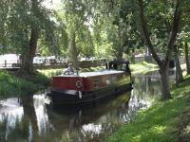 | Dublin Barge Hire operates from Grand Canal Docks in Dublin City.  They offer self-catering accommodation for as little as one night or for a week or more. Their barges are ideal for two adults but can cater up to four adults and two children. This is an opportunity to experience a different view of Dublin.
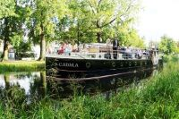 | Moored at Mespil Road on the Grand Canal is the Cadhla Restaurant, a replica of a 1920s barge.  On offer are meals, freshly prepared by their onboard chefs, along with a full range of drinks from the bar. The boat can be booked out in its entirety for private hire such as; weddings, birthdays, product launches, Christmas parties, corporate events, press days, team building meetings, etc. The barge can accommodate up to 48 people on board, while cruising along the canal.
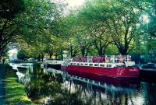 | Also moored along this stretch of the Grand Canal is La Peniche Restaurant on board the barge Riasc.  On offer are lunch and dinner options, plus the boat can be booked out in its entirety for corporate events, weddings, parties.  Cruising dinners are available with an opportunity to not to be missed, and offer an opportunity to experience the barge rising up through a lock and navigating under 18th century bridges, all from the comfort of your table.
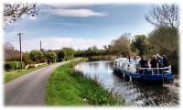 | Further west along the Grand Canal is Bargetrip in Sallins Harbour. Barge Amo carries up to 12 people; your skipper will give you a unique insight into the life and history of the Grand Canal. Setting out from Sallins, you can choose different options, including a one-hour cruise to the Leinster Aqueduct or a two-and-half hour cruise through Digby Lock. You can also hire the barge exclusively for your group. These trips are also an ideal opportunity to experience the rural canals for those thinking about buying their own boat. This stretch of canal is particularly lovely with a rich history.
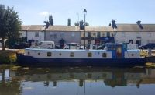 | Also available in Sallins is the Flotel Roisin Dubh, a Houseboat that accommodates from two to six, feels spacious and is ideal for families, groups of friends or a romantic getaway.  Sallins is home to award winning restaurants and pubs. It is easily accessed by road, along the Greenway and from Dublin and elsewhere by train.
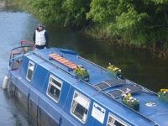 | Jennifers Travels is located on the Barrow Blueway in Bell Harbour, Monasterevin. The Canal here is near the train station and Exit 14 of the M7.  Their barges can accommodate up to four and are available for short term hire along the Grand Canal and River Barrow.
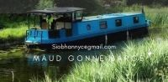 | The Maud Gonne from Blueway Barges, is located in Monasterevin and can accommodate up to four for short or long breaks.
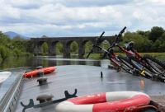 | Barrowline Cruisers is in Vicarstown, on the Kildare-Laois border. Their fleet of self-catering narrowboat and wide-beam barges, accommodate three to eight people. They are fully equipped to explore the full extent of the Grand Canal in Kildare, Dublin, Offaly, to the Shannon or south on the River Barrow. Barges are available by the day, week, or multiple weeks.  Electric and hybrid bikes are available at Barrowway Bikes in Vicarstown, allowing you, friends, and family to explore the Barrow Blueway.
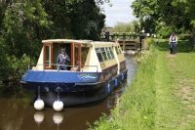 | Athy Boat Tours provides one-to-five-hour tours on the Barrow Navigation.  They work with your group to create a tour for you, whether you wish to enjoy a picnic on board during your tour to Levitstown or lunch on the riverbank during a daylong trip to Maganey.  Their boat is wheelchair accessible.
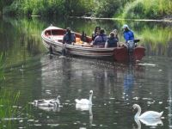 | Boat Trips have open boats on the River Barrow, River Nore and the Barrow Line of the Grand Canal. They provide a historical tour of Kilkenny, a cruise through county Carlow and a wildlife adventure in counties Kildare or Laois.  Check out their site - it has a comprehensive list of all other Boat Tours, Trips, Cruises and Sea Safaris on the Irish coast and inland.
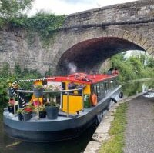 | Royal Canal Boat Trips offer bespoke day charters from Castleknock, Leixlip, Maynooth and Kilcock.  Providing three-hour private charters, including refreshments, the barge can accommodate between two and twelve passengers on each trip.

